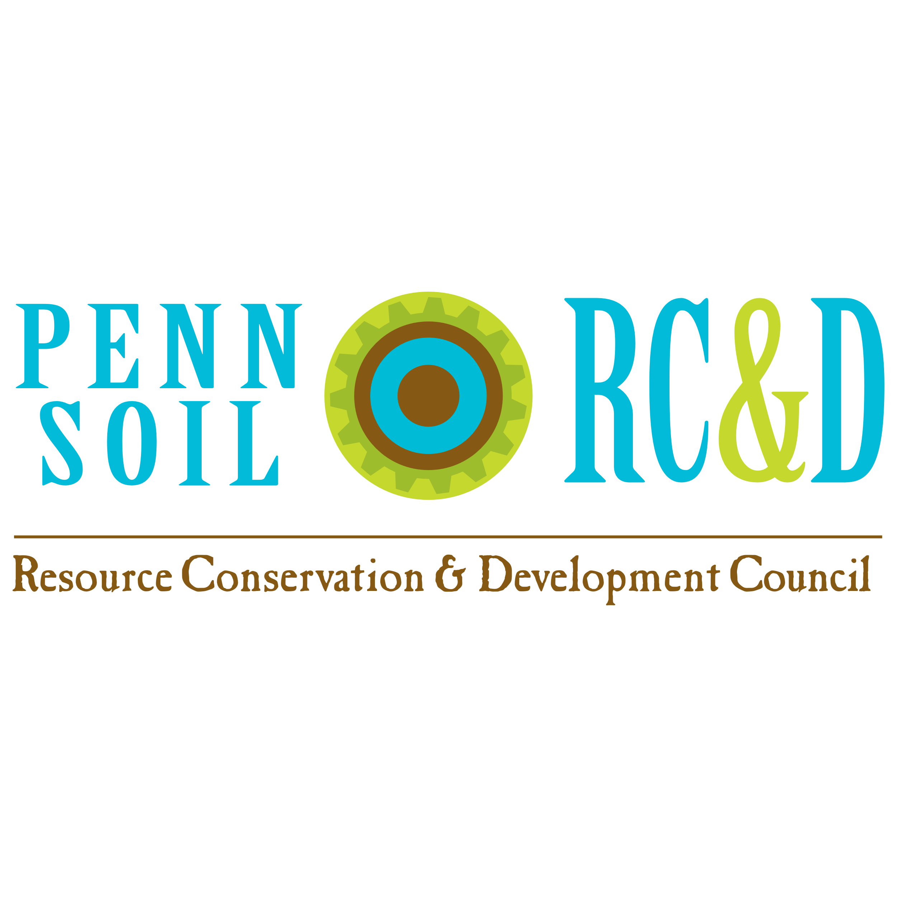
WOMEN’S OUTDOOR WORKSHOPS ARE BACK… WOW!
Penn Soil RC&D Council is the new lead organization of the Women’s Outdoor Workshops, also known as WOW! These all-day outdoor workshops for women and girls 12 years old and up, will rotate around to the 8 counties in the northwest corner of PA that Penn Soil RC&D serves including Clarion, Crawford, Erie, Forest, Lawrence, Mercer, Venango & Warren Counties. The goal is to offer at least 2 events each year in a different county. These events are designed to bring women and girls together for a fun, educational day outdoors, rain or shine, to brush up on old skills, learn new ones without having to buy any equipment to do so and meet new people!
Our second event will be October 17, 2026. Our host location will be the Tionesta Church of God, 1582 PA-36, Tionesta, Pa, 16353, 8 am until about 5 pm.
Important Details : What You Enjoy :
- Registration is $40 (plus any extra material 1. Your choice of 4 expertly taught classes
fees for classes if indicated in description), for presented in an interactive, hands-on
4 - 1 and ¼ hour long workshops, 2 in the morning environment.
and 2 in the afternoon and LUNCH!
2. All equipment and materials provided unless
- Registration deadline is Oct. 5th, 2026 noted in the class description that an extra fee
applies to that class to cover materials fees/kits.
- Class sizes are limited & some classes have
limited sessions, so register early for the best 3. Coffee and donuts during morning registration
chance to get your top 4 choices!! & lunch will be provided by the Women’s Auxiliary
of The Tionesta Church of God!
4. Check in & signing a waiver are required! Plan to
arrive at the Tionesta Church of God between 8 am - 4. Basket raffles and 50/50 drawings will take 8:30 am. Dress for the weather for outside classes. place that day so bring extra cash! These will all be drawn at the end of the day!
- Minimum attendee age is 12 yrs. Ages 12 – 17 must
be accompanied by a parent or guardian & Schedule: 8 – 8:45 am, Registration: 9 – 10:15 am,
take the same classes! 1st workshop session; 10:30 -11:45 am, 2nd workshop session; 11:45 am – 1:00 pm, Lunch; 1:00- 2:15 pm,
- Event is rain or shine. Some workshops will be outdoors & 3rd workshop session: 2:30 – 3:45 pm, 4th session;
some inside. Wear appropriate apparel for variable weather. 3:45 – 4:30, wrap, pull raffle & 50/50 Winners;
4:30 – 5:30, tear down & cleanup!
- Cancellations within 48 hours of the Event will not be
refunded. Substitute attendees are permitted with prior
notice to Penn Soil RC&D for the same classes.

- Bring a refillable water bottle for the day! We will have jugs * If you have sponsor questions or
of ice water and lemonade available throughout the day. would like to donate to the basket
We will not have bottled water! raffle, you can also contact Sue.

If you have questions, you can call
Sue Nielsen at: 814-726-1441 ** As a 501c3 non-profit, donations
OR email to Penn Soil RC&D are 100%
pennsoilrcd@wcconservation.net tax deductible!
Workshop choices
Intro to Beekeeping & Pollinators: Learn about the different bees in the hive and how they work together, how they are critical for pollination of our local agriculture and sample several varies of local honey from the instructor’s own hives!
Blacksmithing Intro: this will cover all basic procedures and techniques, learn to make a steel “S” hook to take home from a master blacksmith! Closed toed shoes recommended and cotton clothing. All materials and safety equipment provided. Two sessions only!
Birdhouse Building Workshop: Participants will learn how to build their own birdhouse to take home from the expert volunteer wood workers of the Toy Shoppe of Warren. You will also learn about their volunteer program in Warren that, for 25 years, has built, painted and distributed roughly 1,800 hand-made wooden toys, for free, to underprivileged children in Warren County and beyond, each year, prior to Christmas! All materials included.
Diamond Painting: An introduction to diamond painting with a cross or butterfly key chain. Include $5 extra with your registration fee to cover material costs.
Forest Bathing: In this workshop, we will put distractions aside as we settle into "being with the plants". We'll focus on our five senses, while exploring sight and touch, hearing, smell and taste. This is a quiet, almost meditative experience. Two sessions only!
Herbal Tincture Making: There are many ways for us to offer and store medicinal herbs. Making herbal tinctures, or alcohol extracts, is but one. This introductory workshop will cover the basic principles of tincturing herbs; we’ll be tasting tinctures and making our own. Each participant will leave with a tincture that they made. Two sessions only! ** Include $5 extra with your registration fee to cover material costs.
Macroinvertebrate/ Water Creature & Fresh Water Mussel Investigation: Dive into a world of wonder—without getting your feet wet! The Discovery Tanks bring the stream to you, teeming with fascinating aquatic critters like crayfish, mayflies, and stoneflies. Explore the hidden life of our waterways in this hands-on, up-close adventure featuring macroinvertebrates and freshwater mussels. Peek into their underwater world, learn how they help keep our streams healthy, and discover why these tiny creatures are big indicators of water quality. It’s hands-on, fascinating, and perfect for curious minds of all ages!
Mosaic Intro: This will be an intro on how to cut stained glass & tile. We’ll talk about different adhesives & substrates for a variety of applications and incorporating natural and repurposed items into a mosaic design. Participants will create their own mosaic masterpiece to take home with no grouting needed. Two sessions only. Limited to the first 20 registrants. ** Include $5 extra with your registration fee to cover material costs.
Native Inspired Leather Pouch making: Learn to cut out leather and stitch the pieces together to make a leather pouch to take home! Participants will also learn to ink stamp on their leather pouch, if desired. Two sessions only! Limited to the first 16 registrants. ** Include $5 extra with your registration fee to cover material costs.

Outdoor Photography: Learn the basics of nature photography with Kirby Neubert with any camera, various camera functions, photography skills and how they affect the finished product, while keeping the technical talk to a minimum. One session only!
Proper Pruning: Ty Ryen, DCNR Service Forester will take participants out to the wood lined property to explain proper pruning of trees & shrubs that participants can try themselves and there will be a brief talk about the tree canopy. Bring your questions about other plants and how to prepare your trees and plants for winter!
Self Defense: This class will present information on observing your surroundings & avoiding dangerous situations. There will be hands-on instruction of defense moves that will show you how to escape an attack safely, info of non-lethal weapons, PA laws regarding self-defense and what to expect after an attack.
Soil Health Investigation: The Hidden World Beneath Your Feet: Become a Soil Life Scientist! Discover the fascinating living world beneath your feet in this interactive soil microbiology workshop. Participants will learn how beneficial bacteria, fungi, protozoa, and nematodes help cycle nutrients, build soil structure, improve water infiltration, and support healthy plants. Through a live microscope experience, each participant will have an opportunity to observe soil organisms, identify what she sees, and discover that she, too, can be a scientist.
Stormwater Runoff, Erosion & Riparian Buffers: Learn how stormwater runoff picks up pollutants and affects our local waterway health, how to minimize excessive runoff and soil erosion on your property, what are riparian buffers and how to incorporate them and rain gardens into a simple stormwater management plan for your property. Participants will also receive information on native and invasive species, plus the how and why it’s important to reduce the spread of invasive hitchhikers.
Windchimes from upcycled materials: Learn how to upcycle items to give them a new life to make a windchime! Participants will learn the basic components needed, choose from provided items to design their windchime, have the opportunity to use a power drill to drill the holes needed to string up pieces and assemble their masterpiece! Materials will be provided. One session only for the first 6 registrants!
Wire wrapping & Lake Erie Beach Glass: Learn to wire weave around a piece of beach glass & make it into a necklace on a black cord or silver chain plus make a bracelet/or keyring. You will learn about Lake Erie beach glass, where it comes from, a brief history of beach combing & good spots in the Lake Erie area to find beach glass. ** Include $5 extra with your registration fee to cover material costs. One session only for the first 12 registered participants!!
Intro to Yoga & Tia Chi: This easy beginner yoga & Tia Chi workshop will introduce proper breathing /relaxation techniques, foundational yoga & Tia Chi moves to feel good in body and mind and increase flexibility and balance. Some chairs will be provided to sit in for some moves and for stability to lean on for standing poses. Please bring a yoga mat if you have one, there will be some to use during the class. One session only for the first 8 registered participants!

Participant Registration Form
** Please Print Legibly
Name:
Address:
City: State: Zip:
Phone #: Date of Birth:
Email: (We’ll send a confirmation email):
Emergency Contact Info: Phone #:
Please choose four (4) first choice classes and four (4) second choices, in case any of the first choices are already filled up for the day. ** Note: any classes that are double sessions fill up 2 time slots. Simply write the name of that class in 2 fields, such as 1 & 2, or 3 & 4.
1.___________________________________________ 2. ____________________________________________
3.___________________________________________ 4. ____________________________________________
Alt. 1. ________________________________________ Alt. 2. ___________________________________________
Alt. 3. _______________________________________ Alt. 4 ____________________________________________
Payment Methods: Pay online via our website at www.pennsoil.org , select the SHOP tab from the page menu and select the icon for WOW Event Registration plus any extra fee icons associated with classes you’re signing up for before you checkout, then Email your signed registration form back to: pennsoilrcd@wcconservation.net
OR
Mail your signed registration form back to: Penn Soil RC&D, 4000 Conewango Ave., Warren, PA 16365. If you didn’t pay your registration fee online, include a check or money order made out to: Penn Soil RC&D (write in Memo line- “WOW”)
** Remember to include with your registration fee any additional costs for class materials!
Participation waiver:
The participant, by signing and submitting this form, acknowledges the program involves some risk. The participant assumes responsibility for her/his actions and for any injury that may result from participation. Furthermore, the participant waives and releases all other participants, the host, sponsors, instructors, the park, officials and/or other parties involved in the event from claims and/or damages/injury in connection with this event.

Signature of Participant: _____________________________________________________________ Date: ________________
Signature of Parent/Legal Guardian of Minor: ____________________________________________________ Date: ________________

Sign here IF you Do Not wish to have your photograph taken or that of a minor by the event photographer and/or used in advertising or publications for this event.
Signature of Participant/Parent/Legal Guardian _________________________________________________ Date: __________________
Name of minor: __________________________________________________________

