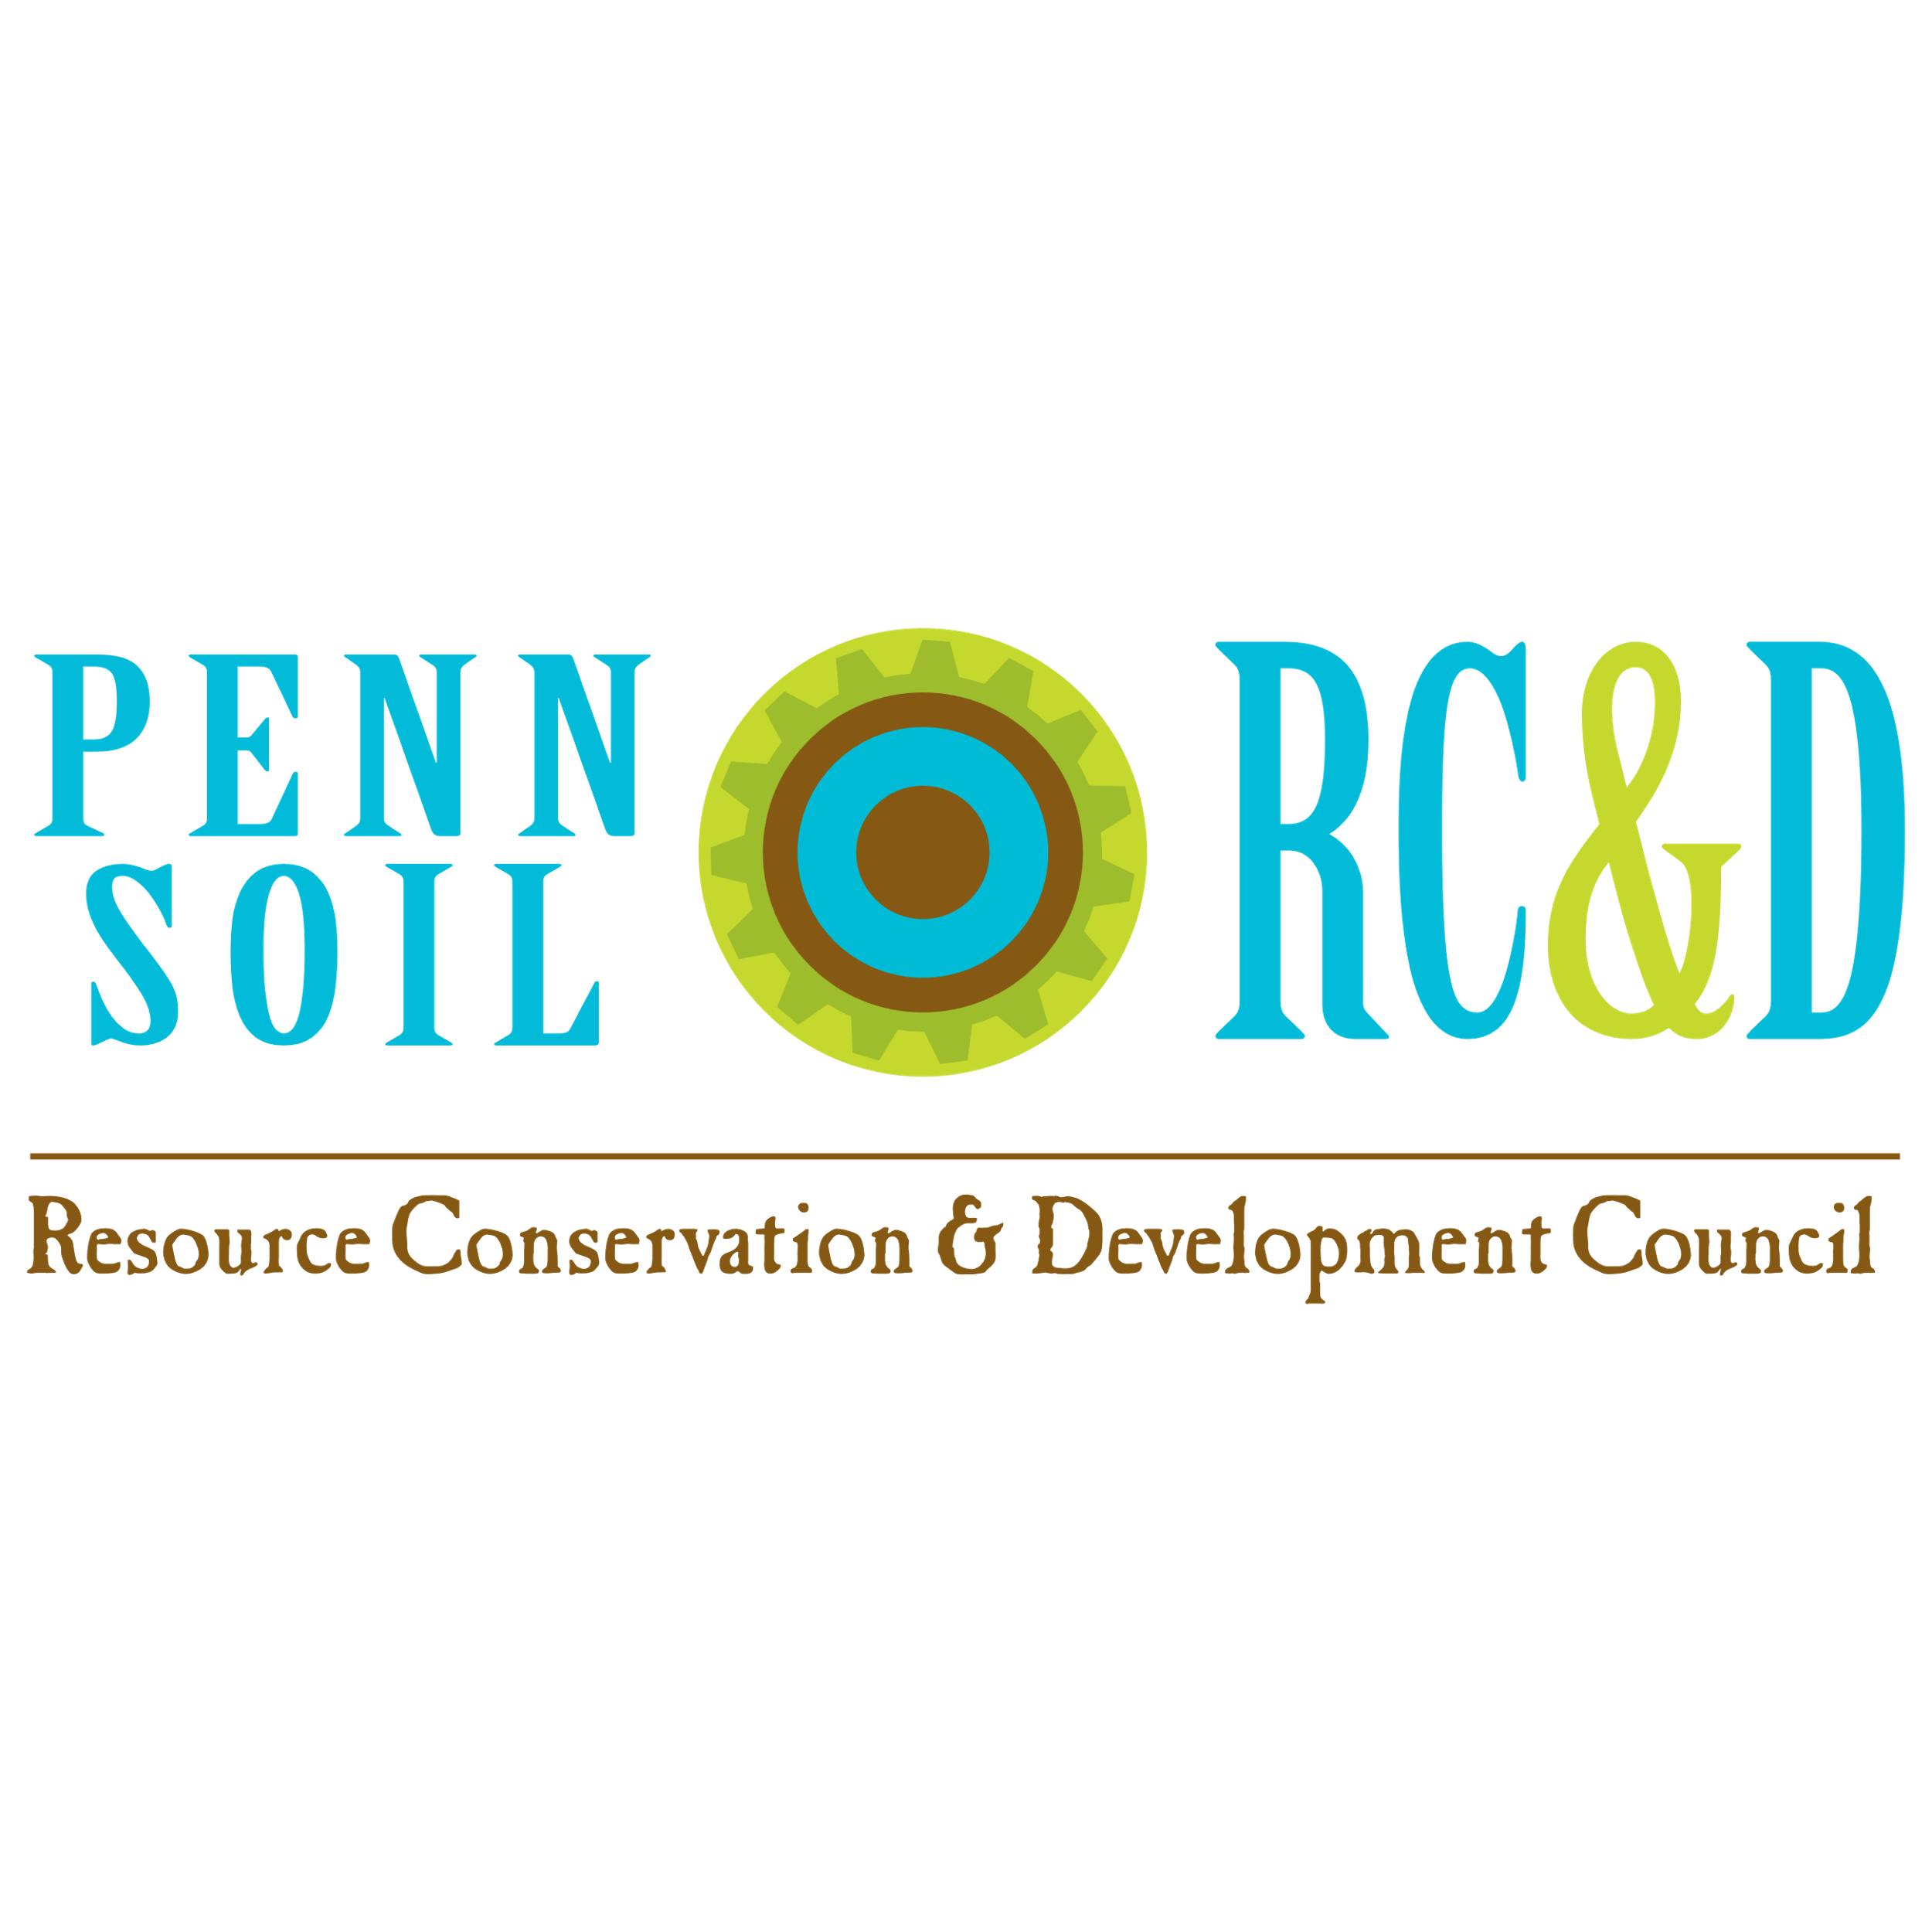
WOMEN’S OUTDOOR WORKSHOPS ARE BACK!
WOW!
Penn Soil RC&D Council is the new lead organization of the Women’s Outdoor Workshops, also known as WOW! These all-day outdoor workshops for women and girls 12 years old and up, will rotate around to the 8 counties in the northwest corner of PA that Penn Soil RC&D serves including Clarion, Crawford, Erie, Forest, Lawrence, Mercer, Venango & Warren Counties. The goal is to offer at least 2 events each year in a different county. These events are designed to bring women and girls together for a fun, educational day outdoors, rain or shine, to brush up on old skills, learn new ones without having to buy any equipment to do so and meet new people!
Our first event will be Saturday, June 20, 2026 at 2 Mile Run County Park, 471 Beach Road, Franklin, PA 16323, 8 am until about 5 pm.
Important Details : What You Enjoy :
- Registration is $40 (plus any extra material 1. Your choice of 4 expertly taught classes
fees for classes if indicated in description), for presented in an interactive, hands-on
4- 1 and ¼ hour long workshops, 2 in the morning environment.
and 2 in the afternoon.
2. All equipment and materials provided unless
- Registration deadline is June 1, 2026 noted in the class description that an extra fee
applies to that class.
- Class sizes are limited & some classes have
limited sessions, so register early for the best 3. Extra activities will take place during the
chance to get your top 4 choices!! Lunch break between 11:45 am and 1 pm.

- Check in & signing a waiver are required! Plan to 4. Basket raffles and 50/50 drawings will take
arrive at 2 Mile Run County Park between 8 am - 8:30 am. place that day so bring extra cash! These will
all be drawn at the end of the day!
- Minimum attendee age is 12 yrs. Ages 12 – 17 must
be accompanied by a parent or guardian & Schedule: 8 – 8:45 am, Registration; 9 – 10:15 am,
take the same classes! 1st workshop session; 10:30 -11:45 am, 2nd workshop session; 11:45 am – 1:00 pm, Lunch; 1:00- 2:15 pm,
- Event is rain or shine and is entirely outdoors! Bring suitable 3rd workshop session; 2:30 – 3:45 pm, 4th workshop
apparel for variable weather and suitable for specific classes. session; 3:45 – 4:30, wrap, pull raffle & 50/50
A change of clothes and towel are recommended. Winners; 4:30 – 6:00, tear down & cleanup!

- Cancellations within 48 hours of the Event will not be If you have questions, you can call
refunded. Substitute attendees are permitted with prior Sue Nielsen at 814-726-1441
notice to Penn Soil RC&D. or email to
pennsoilrcd@wcconservation.net
- Bring a refillable water bottle for the day! We will have jugs
of ice water and lemonade available throughout the day. * If you have sponsor questions or
We will not have bottled water! would like to donate to the basket
raffle, you can also contact Sue.
- Lunch options: Bring a sack lunch or visit the parks Snack
Shack Concession stand. We are also trying to line up a few ** As a 501c3 non-profit, donations
food trucks. We should have more details closer to the event. to Penn Soil RC&D are 100%
tax deductible!
Workshop choices

Archery: Different types of archery covered will include: Compound, Traditional, Cross bow and Genisis Bows. Participants will learn how to shoot them and safety practices for each.
Backpacking & Remote Camping: Different backpacks styles will be available to test out. You’ll learn backpacking skills & safety, what to pack and remote camping will be covered.
Birding Workshop: Kathie Goodblood of the Bartramian Audubon Society will review how to use binoculars, field guides and tips on how to ID birds. Then take the women for a walk to apply these skills. There will be a few pair of binoculars to use, but participants are encouraged to bring their own if they have them. There will only be 2 morning workshops for this class, register early!
Blacksmithing Intro: covers all basic procedures, learn to make a steel “S” hook to take home. Closed toed shoes recommended and cotton clothing. All materials included.
Bluebirds & Nest Box Workshop: Participants will learn about Eastern Bluebirds and how nest boxes can be beneficial in their lives. In this workshop, participants will have the opportunity to build their own nest box to take home. All materials included.
Canoeing basics: This session will give you basics of canoeing: anatomy of a canoe, safety, transporting, and basic paddle strokes. You’ll also experience how solo canoeing is not just paddling. Watch and learn from the experts how canoeing can translate into dancing on the water! Equipment provided.
Emergency/Wilderness Survival Tips: Learn what to take on hikes or trips into nature including simple, low-cost supplies to be prepared for emergencies, how to purify water for drinking and what you can use in nature to shelter in place if you become stranded overnight.
Fly Fishing: This class will explain the fly rod, reel line & accessories needed to fly cast and fish. This will include hands-on learning of several different types of fly casting.
Forest Bathing: In this workshop, we will put distractions aside as we settle into "being with the plants". We'll focus on our five senses, while exploring sight and touch, hearing, smell and taste. This is a quiet, almost meditative experience. One session only, open to the first 15 registered!
Fur Taking: You will learn why we need trapping, equipment, location for different species and baits and lures. You will also learn about sets for different species and a little bit about fur handling.
Herbal Tinctures: There are many ways for us to offer and store medicinal herbs. Making herbal tinctures, or alcohol extracts, is but one. This introductory workshop will cover the basic principles of tincturing herbs; we’ll be tasting tinctures and making our own. Each participant will leave with a tincture that they made. One session only, open to the first 15 registered! ** Include $5 extra with your registration fee to cover material costs.
Kayaking Intro & Water Safety: **This is a double session that will span 2 normal session time slots. You will learn basic water safety, the parts of a kayak, PA boating laws and regulations, how to load & unload a kayak from your vehicle, portaging around hazards, hand signals, how to get in and out of a kayak, stopping, starting, basic strokes, turns, how to use a throw bag and more from a certified instructor and the PA Fish & Boat Commission!
Macroinvertebrate/ Water Creature Investigation: Learn what macroinvertebrates are and where to find them, why they are important to water quality and what critters in streams and creeks indicate about water quality.

Mosaic Intro: This will be an intro on how to cut stained glass & tile. We’ll talk about different adhesives & substrates for a variety of applications and incorporating natural and repurposed items into a mosaic design. Participants will create their own mosaic masterpiece to take home with no grouting needed. One session only, open to the first 8 registrants. ** Include $5 extra with your registration fee to cover material costs.
Mountain Biking Intro: The clinic will teach women and girls the fundamentals of mountain biking from safety, functions of bike components, and safe riding on the trail.
Native & Invasive Insects & Plants: Master Gardeners will engage participants with how to identify common native species, understand their roles in the ecosystem, and recognize the threats posed by invasives. The program also highlights the importance of protecting beneficial native insects that support healthy gardens and landscapes.
Outdoor Photography: Learn the basics of nature photography with Kirby Neubert with any camera, various camera functions, photography skills and how they affect the finished product, while keeping the technical talk to a minimum.
Proper Pruning: Ty Ryen, DCNR Service Forester will take participants out on a trail to explain proper pruning of trees & shrubs that participants can try themselves and there will be a brief talk about the tree canopy. Bring your questions about other plants as well!
Self Defense: This class will present information on observing your surroundings & avoiding dangerous situations. There will be hands-on instruction of defense moves that will show you how to escape an attack safely, info of non-lethal weapons, PA laws regarding self-defense and what to expect after an attack.
Starter Herb Garden: Make a starter herb garden to take home & learn what different herbs are commonly used for. Materials included.
Stress Less with Nature: Through interactive discussion, participants will learn how practicing mindfulness and spending time in nature can reduce negative impacts of stress, balance mood, and support physical health. This experiential learning workshop will include facilitated activities such as breathwork, meditation, and sensory grounding, and participants will receive guidance to continue this practice beyond the weekend for continued wellness.
Rock Painting & Nature as Inspiration for Art: Artist and outdoors enthusiast, Jesse Wolfgang, will bring flat rocks, paints, and brushes for each participant to create a nature inspired masterpiece to take home. You bring your imagination for a relaxing rock painting session in nature.
Easter Egg Etching: **This is a double session that will span 2 normal session time slots. You’ll learn the ancient practice of decorating an egg with wax and dyes. Each person will create their own unique design on an egg, layering wax and dyes, learn how to remove the egg whites and yolk and take their decorated egg home.
Wire wrapping & Lake Erie Beach Glass: Learn to wire weave around a piece of beach glass & make it into a necklace on a black cord or silver chain. You will learn about Lake Erie beach glass, where it comes from, a brief history of beach combing & good spots in the Lake Erie area to find beach glass. Include $5 extra with your registration fee to cover material costs.
Yoga: This beginner yoga workshop will break down foundational yoga postures and flows to feel good in body and mind. Please bring a yoga mat if you have one, there will be some to use during the class.

Participant Registration Form
** Please Print Legibly
Name:
Address:
City: State: Zip:
Phone #: Date of Birth:
Email: (We’ll send a confirmation email):
Emergency Contact Info: Phone #:
Please choose four (4) first choice classes and four (4) second choices, in case any of the first choices are already filled up for the day. ** Note: any classes that are double sessions fill up 2 time slots. Simply write the name of that class in 2 fields, such as 1 & 2, or 3 & 4.
1.___________________________________________ 2. ____________________________________________
3.___________________________________________ 4. ____________________________________________
Alt. 1. ________________________________________ Alt. 2. ___________________________________________
Alt. 3. _______________________________________ Alt. 4 ____________________________________________
Payment Methods: Pay online via our website at www.pennsoil.org , select the SHOP tab from the page menu and select the icon for WOW Event Registration plus any extra fee icons associated with classes your signing up for before you checkout, then Email your signed registration form back to: pennsoilrcd@wcconservation.net
OR
Mail your signed registration form back to: Penn Soil RC&D, 4000 Conewango Ave., Warren, PA 16365. If you didn’t pay your registration fee online, include a check or money order made out to: Penn Soil RC&D (write in Memo line- “WOW”)
** Remember to include with your registration fee any additional costs for class materials!
Participation waiver:
The participant, by signing and submitting this form, acknowledges the program involves some risk. The participant assumes responsibility for her/his actions and for any injury that may result from participation. Furthermore, the participant waives and releases all other participants, the host, sponsors, instructors, the park, officials and/or other parties involved in the event from claims and/or damages/injury in connection with this event.

Signature of Participant: _____________________________________________________________ Date: ________________
Signature of Parent/Legal Guardian of Minor: ____________________________________________________ Date: ________________

Sign here IF you Do Not wish to have your photograph taken or that of a minor by the event photographer and/or used in advertising or publications for this event.
Signature of Participant/Parent/Legal Guardian _________________________________________________ Date: __________________
Name of minor: __________________________________________________________

